**I. How to open App Show map of iOS:**

location = 37.31949939188675,126.8701171875;

Dictionary *param = [[Dictionary alloc]initWithObjectForKey:location,@“location”,nil];

NSString* strLoc = [param objectForKey:@"location"];

NSString* strUrl = [NSString stringWithFormat:@"http://maps.google.com/maps?q=%@",

[strLoc stringByAddingPercentEscapesUsingEncoding:NSUTF8StringEncoding]];

[[UIApplication sharedApplication] openURL: [NSURL URLWithString:strUrl]];

**II.** [**Creating a Static Library in iOS Tutorial**](http://www.raywenderlich.com/41377/creating-a-static-library-in-ios-tutorial)**:**

**Link:** http://www.raywenderlich.com/41377/creating-a-static-library-in-ios-tutorial

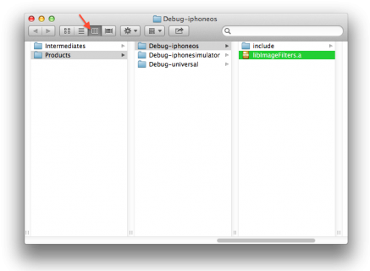

**III. How ot init Xib:**

**Link: http://stackoverflow.com/questions/4763519/loaded-nib-but-the-view-outlet-was-not-set-new-to-interfacebuilder**

* Open the XIB file causing problems
* Click on file's owner icon on the left bar (top one, looks like a yellow outlined box)
* If you don't see the right-hand sidebar, click on the third icon above "view" in your toolbar. This will show the right-hand sidebar
* In the right-hand sidebar, click on the third tab--the one that looks a bit like a newspaper
* Under "Custom Class" at the top, make sure Class is the name of the ViewController that should correspond to this view. If not, enter it
* In the right-hand sidebar, click on the last tab--the one that looks like a circle with an arrow in it
* You should see "outlets" with "view" under it. Drag the circle next to it over to the "view" icon on the left bar (bottom one, looks like a white square with a thick gray outline
* Save the xib and re-run

**IV. Primitive type and Containeres:**

Property lists are based on an abstraction for expressing simple hierarchies of data. The items of data in a property list are of a limited number of types. Some types are for primitive values and others are for containers of values. The primitive types are strings, numbers, binary data, dates, and Boolean values. The containers are arrays—indexed collections of values—and dictionaries—collections of values each identified by a key. The containers can contain other containers as well as the primitive types.

Ref:<https://developer.apple.com/library/mac/documentation/Cocoa/Conceptual/PropertyLists/AboutPropertyLists/AboutPropertyLists.html>

**V. UIActionSheet and UIPopoverController:**

Ref: http://www.appcoda.com/uiactionsheet-uipopovercontroller-tutorial/

UIActionSheet *actionSheet = [[UIActionSheet alloc] initWithTitle:@"What do you want to do with the file?" delegate:self cancelButtonTitle:@"Cancel"

destructiveButtonTitle:@"Delete it" otherButtonTitles:@"Copy", @"Move", @"Duplicate", nil];

[actionSheet showInView:self.view];

- Then,

@interface ViewController : UIViewController <UIActionSheetDelegate>

- Add Tag to UIActionSheet to notices which action was selection and index of button of Action sheet use:

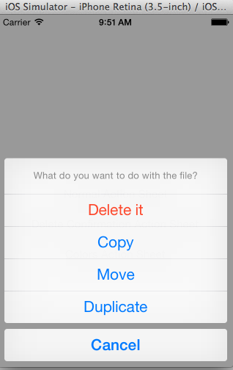// showNormalActionSheet:

actionSheet.tag = 100;

// showDeleteConfirmation:

actionSheet.tag = 200;

// showColorsActionSheet:

actionSheet.tag = 300;

Check Click and dissmiss:

-(void)actionSheet:(UIActionSheet *)actionSheet

clickedButtonAtIndex:(NSInteger)buttonIndex{

    if (actionSheet.tag == 100) {

        NSLog(@"The Normal action sheet.");

    }

    else if (actionSheet.tag == 200){

        NSLog(@"The Delete confirmation action sheet.");

    }

    else{

        NSLog(@"The Color selection action sheet.");

    }

    NSLog(@"Index = %d - Title = %@", buttonIndex,

[actionSheet buttonTitleAtIndex:buttonIndex]);

}

-(void)actionSheet:(UIActionSheet *)actionSheet

didDismissWithButtonIndex:(NSInteger)buttonIndex{

    if (actionSheet.tag == 300) {

        NSLog(@"From didDismissWithButtonIndex - Selected Color: %@",

[actionSheet buttonTitleAtIndex:buttonIndex]);

    }

}

-(void)actionSheet:(UIActionSheet *)actionSheet

willDismissWithButtonIndex:(NSInteger)buttonIndex{

    if (actionSheet.tag == 300) {

        NSLog(@"From willDismissWithButtonIndex - Selected Color: %@",

[actionSheet buttonTitleAtIndex:buttonIndex]);

    }

}

**VI. Check Type of Device:**

if (UI_USER_INTERFACE_IDIOM() == UIUserInterfaceIdiomPad) {

        // In this case the device is an iPad.

    }

    else{

        // In this case the device is an iPhone/iPod Touch.

        [actionSheet showInView:self.view];

    }

**VII. Property Attributes:**

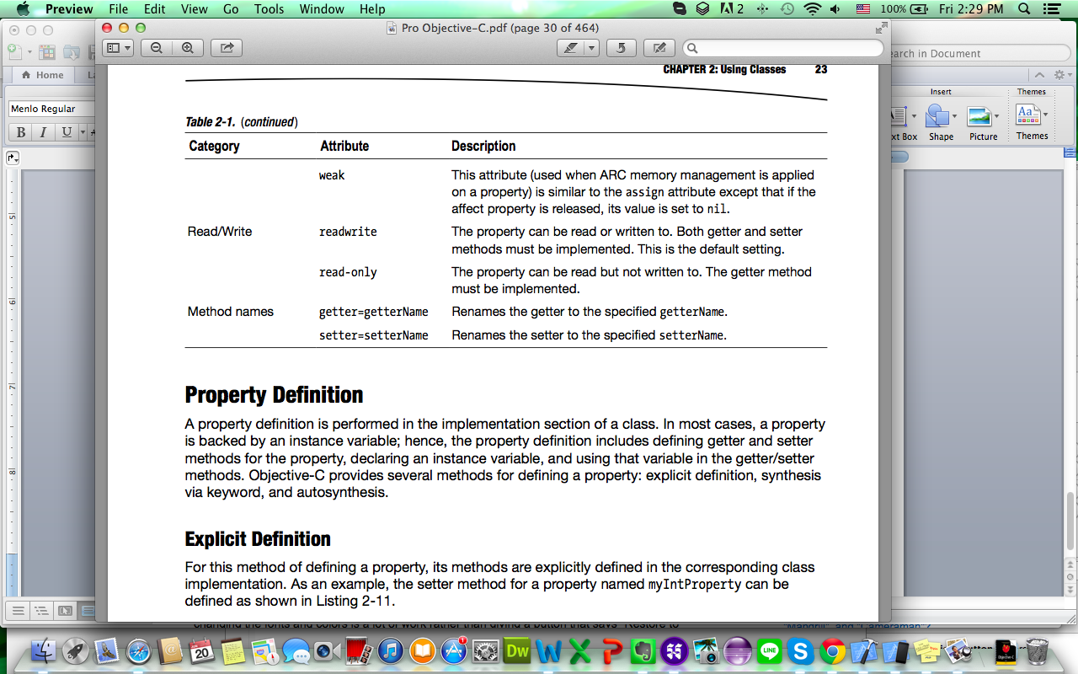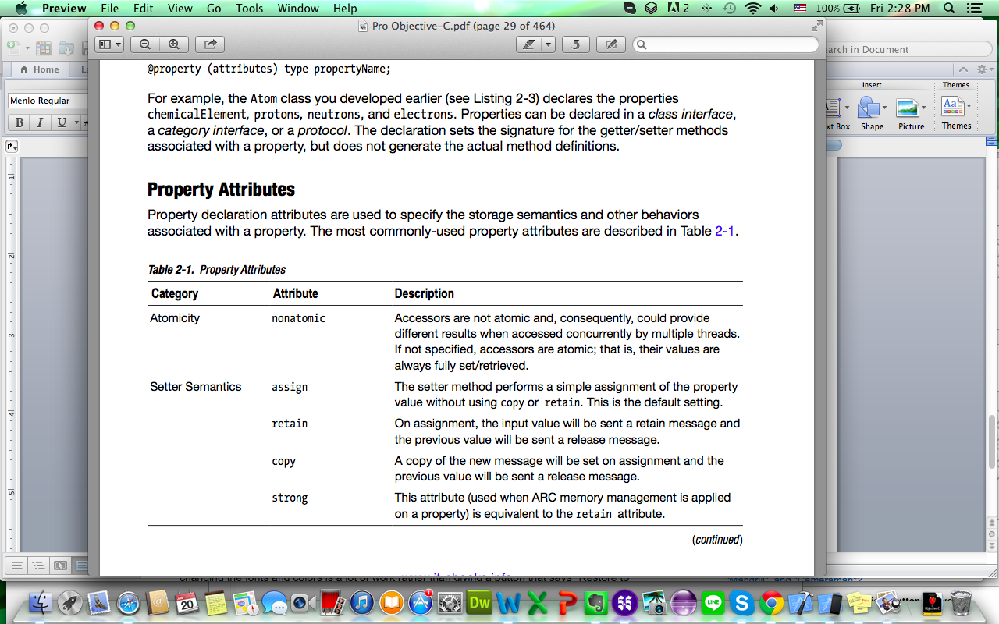

**VII. JQuery:**

$("#contact").click(**function**(){

bizMOB.Native.addcontact ("person");

});

**- Call in bizMOBWeb:**

bizMOB.Native.addcontact = **new** Object();

bizMOB.Native.addcontact = **function**(type){

**var** v = {

"call_type": "js2app",

"id": "SHOW_NATIVE_CONTACT_VIEW",

"param": {type:type}

};

bizMOB.onFireMessage(v);

**return**;

};

$("#tmcm_btn").click(**function**(){

bizMOB.teruten.setProtection(

{

TYPE_CAPTURE : **false**

}, {});

});

**- Call in bizMOBWeb:**

**.ios_protection : create as array of object**

**.adroid_protection : create as array of object.**

**.var ios_p : $.extend(true,{},ios_protection) mean extend or add**

**more varaiable as array in ios_p.**

bizMOB.teruten.setProtection = function(ios_protection, android_protection){

**var** v = {

                     call_type : "js2app",

                     id : "TMCM_PROTECTION",

                     param : {}

              };

**var** ios_p = $.extend(**true**, {

                     TYPE_JAILBREAK : **false**,

                     TYPE_HDMI : **false**,

                     TYPE_CAPTURE : **false**

              }, ios_protection);

**var** android_p = $.extend(true, {

                     TYPE_ROOTING : **false**,

                     TYPE_EMULATOR : **false**,

                     TYPE_HDMI : **false**,

                     TYPE_MIRACAST : **false**,

                     TYPE_USB : **false**,

                     TYPE_BLUETOOTH : **false**,

                     TYPE_DATANET : **false**,

                     TYPE_WIFI : **false**,

                     TYPE_PROCESS : **false**,

                     TYPE_REMOTE : **false**,

                     TYPE_SHORTKEY : **false**

              }, android_protection);

**if**(bizMOB.detectAndroid()) {

v.param = android_p;

      }

**else** **if**(bizMOB.detectiPhone()) {

v.param = ios_p;

      }

              bizMOB.onFireMessage(v);

       };

**VI. Quick Command for Testing in Xcode:**

* **Po : command use in console to print every object in Xcode**

**ex:**

//Display all Viewcontrollers which already loaded.

**(lldb)** po [[[[UIApplication sharedApplication] delegate] navigationController]

viewControllers]

------------------------------------------

id obj=[TscCLibModule getTopController];

**(lldb)** po obj

* **command + / : put // for comment code**
* **command + click on varirable or method : find quick in Xcode.**

**VII. How to cut string in Xcode:**

NSRange fstr,fstr1;

fstr= [strUrl rangeOfString:@"id="];

fstr1 =[strUrl rangeOfString:@"&ext"];

NSString *path=nil;

if( fstr.location != NSNotFound && fstr1.location != NSNotFound)

{

NSString* temp = [strUrl substringWithRange:

NSMakeRange(fstr.location+3,fstr1.location-(fstr.location+3))];

// 확장자

NSString* ext = [strUrl substringWithRange:

NSMakeRange(fstr1.location+5,[strUrl length] - (fstr1.location+5))];

//[temp stringByAppendingString:ext];

// 파일이름에 확장자

NSString* filename = [NSString stringWithFormat:@"%@.%@",temp,ext];

}

po strUrl => assets-library://asset/asset.PNG?id=7B6A43C5-910D-4B9B-B7B5-AB3555044A62&ext=PNG

**VIII. Create Folder Reference for asset in bizMOB 3.0:**

Folder reference stay in blue color and when you copy something in that folder it will be come auto in project of our xcode. Now, create folder reference with assets folder as bellowed:

1. Just Add New File to project
2. Then, select create folder reference
3. So you will get the folder reference in blue color and you test and copy anything in that folder
4. After, it will come auto in Xcode project.

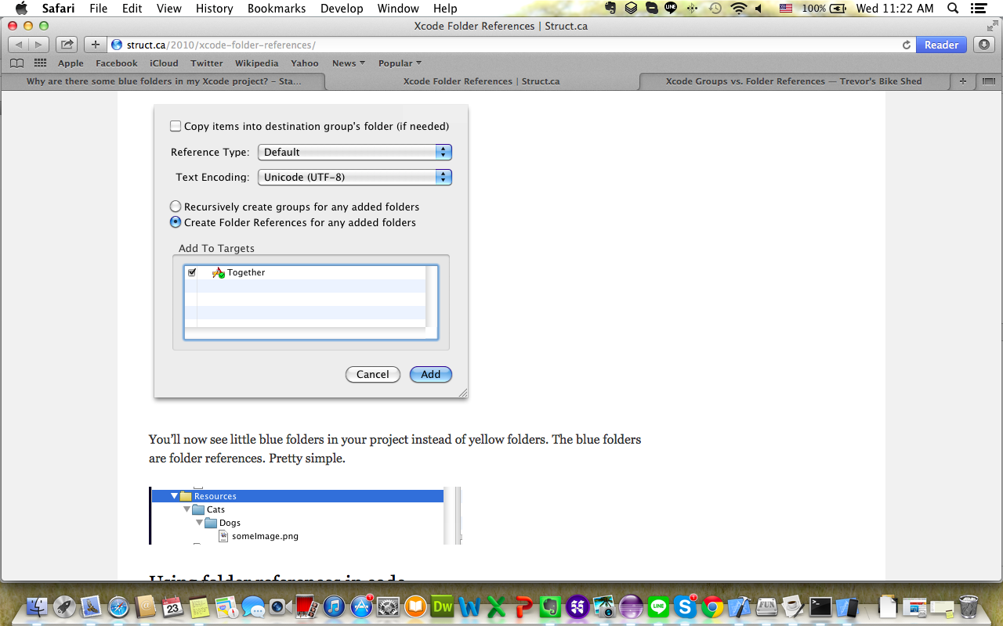

**XV. How to change status text color ios.7.0:**

1. Set the UIViewControllerBasedStatusBarAppearance to YES in the .plist file.
2. In the viewDidLoad do a [self setNeedsStatusBarAppearanceUpdate];
3. Add the following method:

-(UIStatusBarStyle)preferredStatusBarStyle{

return UIStatusBarStyleLightContent;

}

---------------

link: http://stackoverflow.com/questions/17678881/how-to-change-status-bar-text-color-in-ios-7

1. Display Item in TableView:

<http://www.appcoda.com/ios-programming-tutorial-create-a-simple-table-view-app/>

2. Passing Data from UITableview to ViewDetailController :

<http://www.appcoda.com/storyboards-ios-tutorial-pass-data-between-view-controller-with-segue/>

3. Add BarButtom Program : <http://iphone-tora.sakura.ne.jp/uitoolbar.html>

4. UITableView in alert:

<http://www.appcoda.com/storyboards-ios-tutorial-pass-data-between-view-controller-with-segue/>

5. Sample Table View:

<http://www.appcoda.com/ios-programming-tutorial-create-a-simple-table-view-app/>

6. Check file exist in Folder:

<http://stackoverflow.com/questions/1638834/how-to-check-if-a-file-exists-in-documents-folder>